Flutter Roadmap

Stage 06 – Flutter Widgets Fundamentals

Prepared by:
Momen Mohammed Kraizem
Computer Engineering Graduate
20 July 2026

Login Screen


Registration Screen
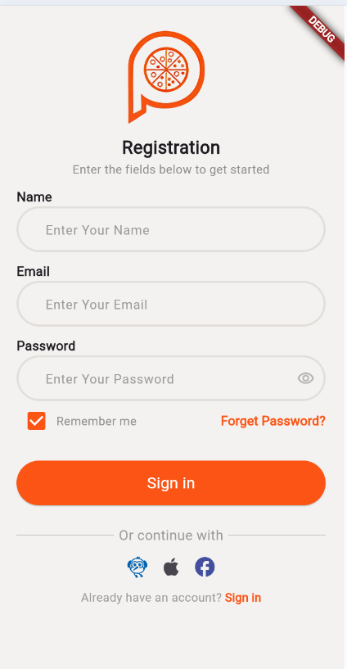

Home Screen


Products Screen
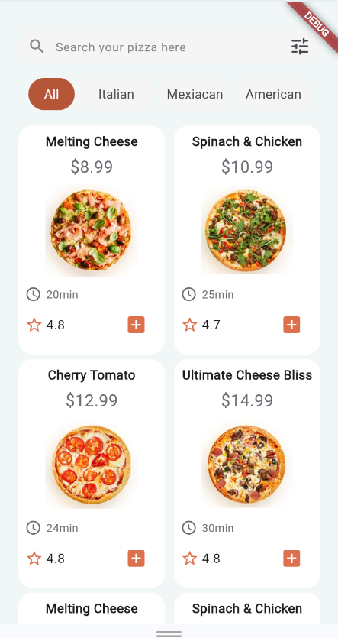

Profile $ Setting Screen
